COURSE ENROLLMENT FORM
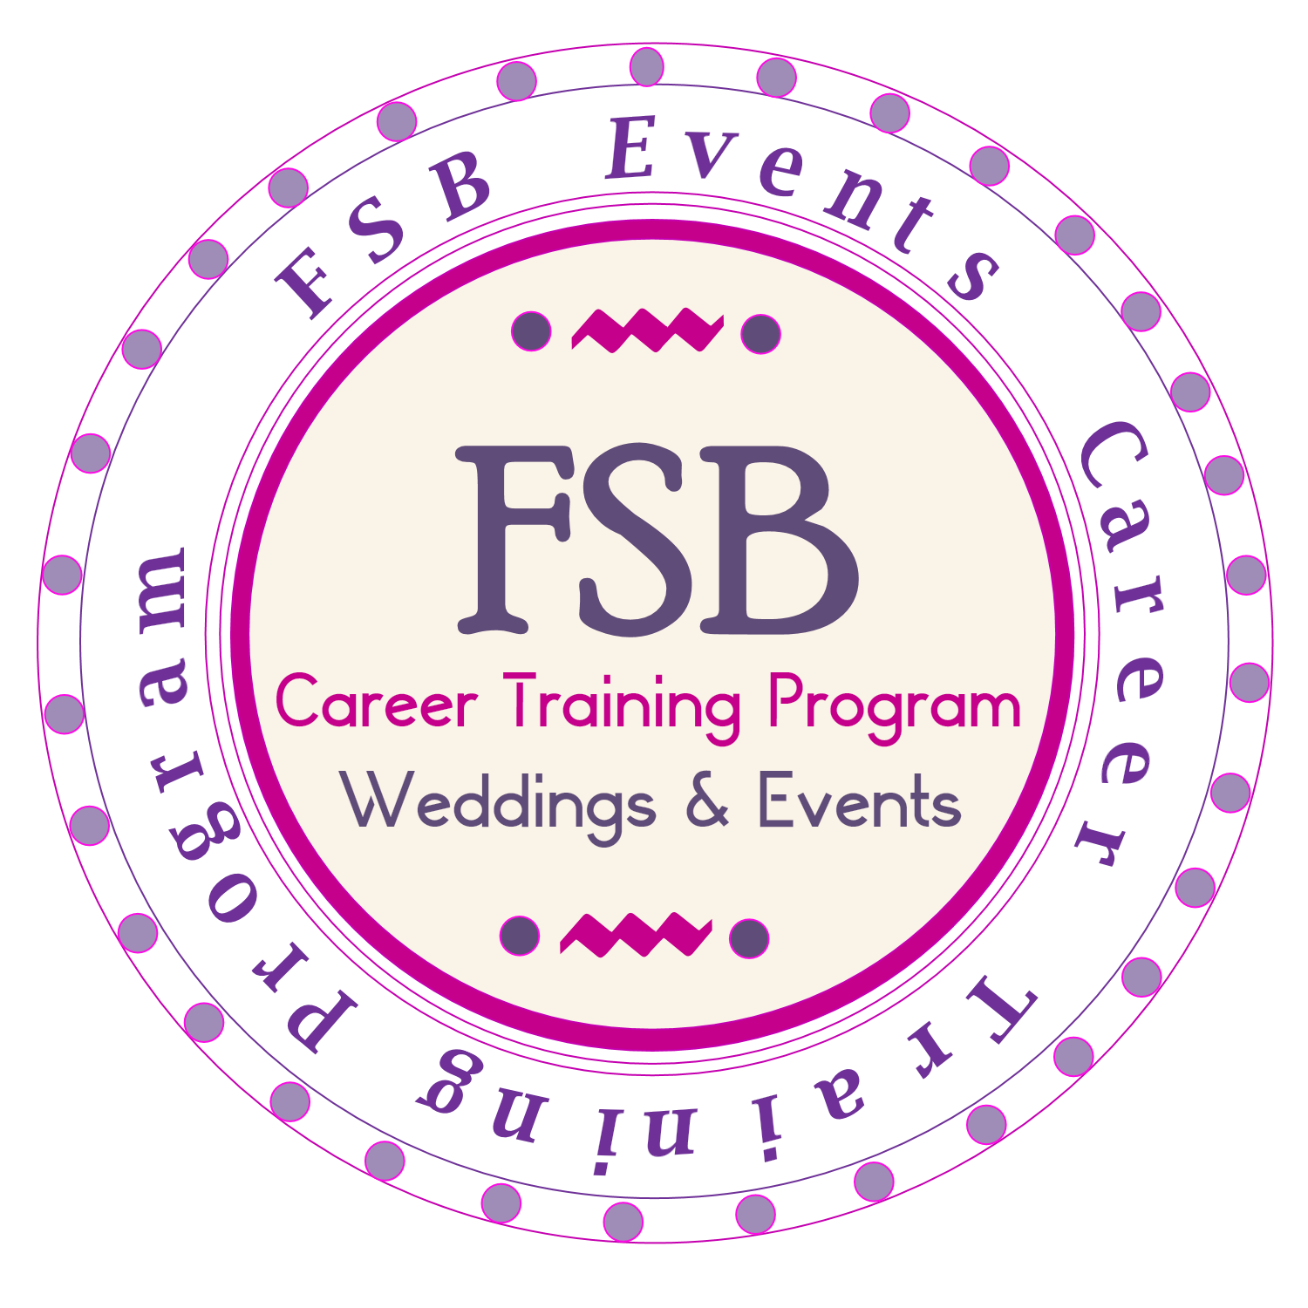
W: www.fsb-events.com I : P: 404.216.0047 I E: classes@fsb-events.com

____________________________________________________________________________

COURSE REGISTRATION ENROLLMENT FORM: Today’s Date: _____________

Full Name: __________________________________ Mailing address: ___________________City_________
(Last) (First)

State: _______ Zip: _______________Email Address: ____________________ Cell Phone: ___________________

How would you like to take the course, (Select X)

Atlanta Class ___ Home Study Self-Paced _____ Online _____

I _______________________________________ am requesting to enroll in a class with FSB Events Career Training Program, that’s scheduled to starts on (Date) _________________.

Payment Options: Full Payment of ________ I would like the TWO payment options ________

Please pay 125.00 registration fees along with this enrollment form to officially be on our class schedule. Registration fee is non refundable but can be transferred to another class that’s scheduled within 3 months. Registration fee goes towards class total fee. (Class final payments are due 1 week before class starts.)

Payments can be made: Cash app ($FSBEvents) or paypal.me/FSBEventsPlanning

Cancellation Policy:

- I understand that I can cancel my enrollment up to 2 weeks before the class starts, and will be given a refund EXCEPT an enrollment hold fee of 75.00 (Initial __________). Please allow 14 days for the refund. There is no refund once you have started the class, however you can reschedule your class at any time up to 6 months. (Student must check our class availability.) Please note any changes to these terms will be advised upon of enrollment.
- PLEASE NOTE: Online & Atlanta CLASSES ARE BASED ON HEAD COUNT ENROLLMENT.
If an Atlanta class do not meet headcount requirement, class may be changed to an online class. Students also have the option to change to the Home study Self-Paced. Student will be refunded the different in cost if that applies. FSB Events reserves the right to cancel these classes at any time if we do not meet the minimum enrollment requirements. A total refund is given in this case.

If a student selects to take the self-paced homes study course and the course has been emailed, there is no refund in this case.
Email us enrollment form at classes@fsb-events.com. If you have additional questions? Call FSB Events, 404.216.0047

By signing this enrollment form you are registering in FSB Events Career program classes.

____________________________ ___________________________
Signature Date

